MycorrhizaFinder ErM Classification Guidelines

General: The manual labelling process should be guided by clearly defined criteria whilst being intuitive. Given a central image tile, experts should label as though assessing through a microscope given the context of the surrounding 8 tiles, while following the guidelines presented herein. This document aims to define clear classification criteria for all classes encountered, which can be used across numerous researchers to curate a new training dataset.
Class | Criteria
[Bl+] Blue coils | Must exhibit at least one of the following image features:  - Thin, septate, blue-stained hyphal coils  - Wavy, septate extracellular hyphae  Amount of colonisation required:  - No minimum requirement but hyphae must clearly be coiling within the confines of the cell walls  Exemplary images:  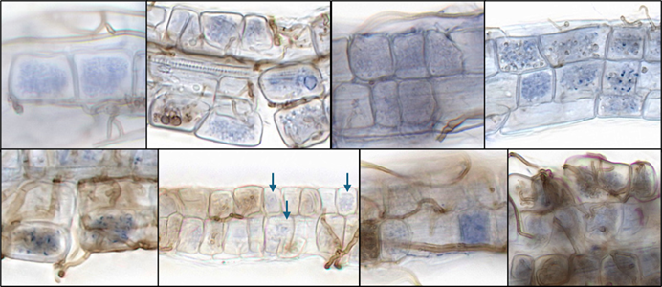  Other aspects to be aware of:  - Colouration may vary between blue and light brown  - Surface hyphae may partially obscure coils  - May have brown extracellular hyphae connecting to blue coil inside cell  - Relevant in hair roots only
[Br+] Brown coils | Must exhibit at least one of the following image features:  - Thin septate brown hyphal coils  - Standard brown extracellular hyphae  Amount of colonisation required:  - No minimum requirement but hyphae must clearly be coiling within the confines of the cell walls  Exemplary images:  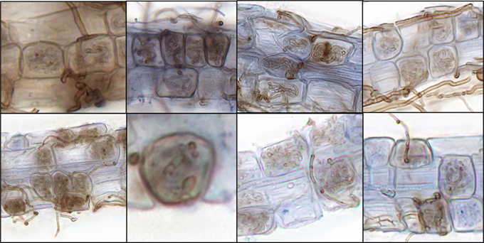  Other aspects to be aware of:  - Colouration may vary between blue and brown  - Surface hyphae may partially obscure coils  - Relevant in hair roots only
[T+] Type 2 | Must exhibit following image features:  - Thick, septate, wavy extracellular hyphae; stains blue  Amount of colonisation required:  - No minimum requirement but hyphae must clearly be coiling within the confines of the cell walls  Exemplary images:  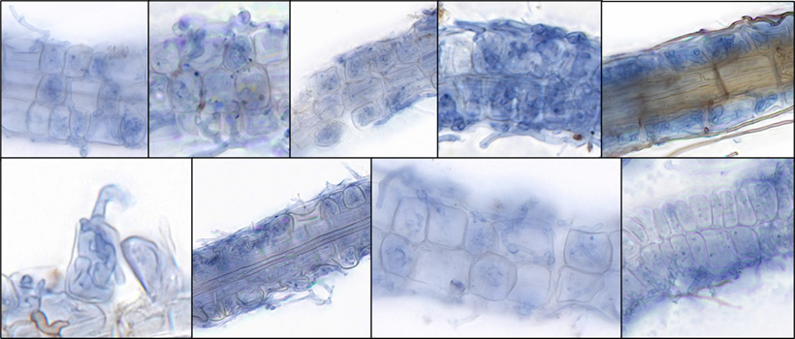  Other aspects to be aware of:  - Relevant in hair roots only  - Can look like DSE, but blue-staining
[N-] Non-colonised root | Must exhibit the following image features:  - Lack of blue, brown, or Type-2 coils  - Lack of DSE  Amount required:  - At least 10% of tile contains root  Exemplary images:  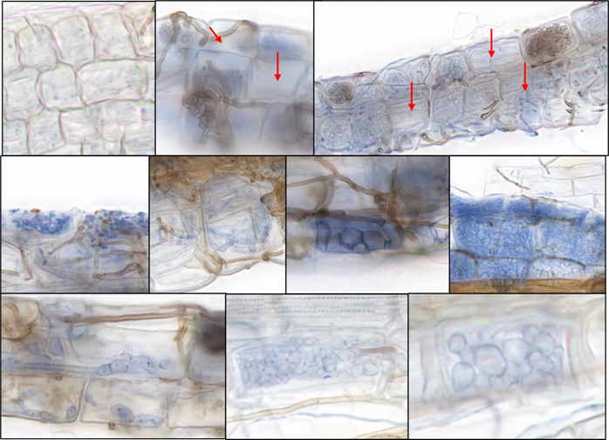  May contain:  - Relevant in hair roots only  - Sclerotia, Bacteria, unidentified structures  - May have blue or brown extracellular hyphae over the top
[D] DSE | Must exhibit one of the following image features:  - Thick, septate, dark brown hyphae, irregular width  - Dark brown microsclerotia/spores  - Sclerotia/hyphae within cells  Amount required:  - No minimum requirement but structures must be clearly visible within a cell  Exemplary images:  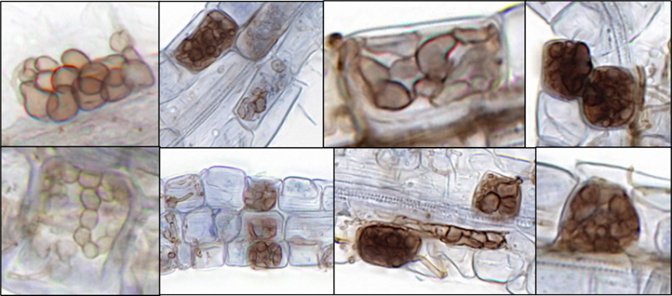  Other aspects to be aware of:  - Relevant in hair roots only  - Might look like Type II but does not stain blue.
[X] No root | Must exhibit the following features  - No cell walls are visible  Amount required:  - Less than 10% of tile includes cell walls  Exemplary images:  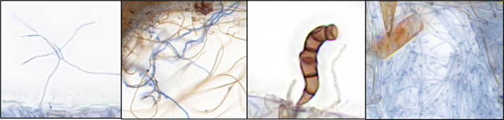  Other aspects to be aware of:  May include bubbles, specks of dust, flecks of dirt, extracellular hyphae, spores and other floating fungal structures
[M] Main root | Must exhibit the following features:  - Larger cells than hair roots  Amount required:  - At least 10% of tile contains root  Exemplary images (small fragment of hair root included for comparison):  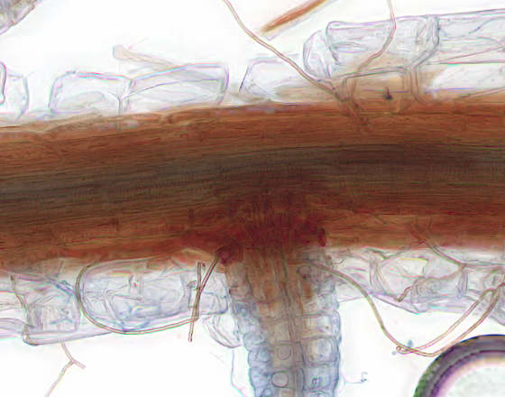  Other aspects to be aware of:  - Darker stain  - Presence of DSE  - Cells lignified  - Cells more rectangular than hair root cells
[U] Unreadable | Designed for tiles that cannot be assessed by an expert. May exhibit following image features:  Structures too blurry to assess, root too obscured by dirt to assess, stain too dark to see structures, too much extracellular hyphae to determine colonization inside root, unconfirmed hyphal structures.  Amount required:  - At least 50% of the tile is unreadable  Exemplary images:  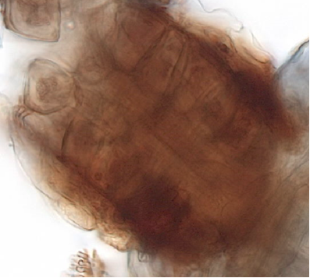  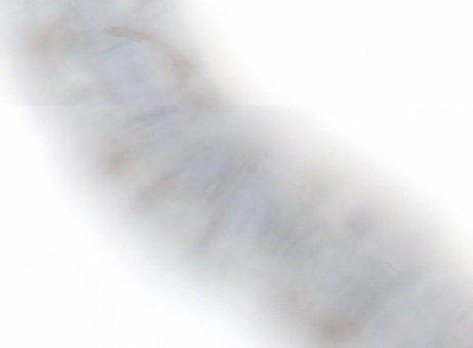  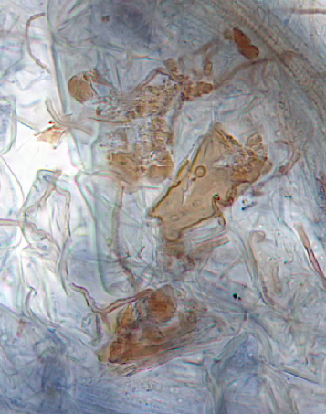  Other aspects to be aware of:  - Relevant in hair roots only
[HE+] Hybrid ErM | Must exhibit a at least two of the following image features:  - Blue coils  - Brown coils  - Type 2  Amount required:  - No minimum requirement but hyphae must clearly be coiling within the confines of the cell walls  Exemplary images:  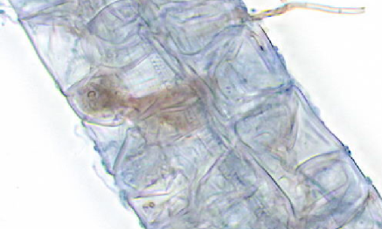  Other aspects to be aware of:  - Relevant in hair roots only  - One may be dominant, but if both features are visible, it should still be included in this category.
[HD+] Hybrid DSE | Must exhibit:  - Blue coils, brown coils, or Type-2  - DSE  Amount required:  - No minimum requirement but hyphae must clearly be coiling within the confines of the cell walls  Exemplary images:  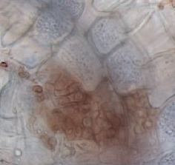  Other aspects to be aware of:  - Relevant in hair roots only  - One may be dominant, but if both features are visible, it should still be included in this category.

